Nirmala Arts and Science College Mulanthuruthy Department of Computer Applications
List Of Programmes(2020-21)
Date | Programme | Programme  Coordinators
7-08-20 | Webinar on Basics of Web Development | Mr. Eldho Peter  Mrs. Jeena Varghese
24-08-20 | International Webinar on Python | Mrs. Chinju  Kuriachan
5-09-20 | Teachers Day Celebration | Department Students
28-09-20 to 30-09- | Faculty Exchange Program | Mrs. Steffy k
20 |  | Vargheese
 |  | Mrs. Jeena Vargheese

 |  |  |  |  |  | college Poothotta
16-11-20 |  |  | Webinar on Future Artificial Intelligence | with | Mrs. Steffy K Vargheese | Mr. Adarsh V Kumar  Artificial Intelligence Developer, AI Village
02-12-20 |  |  | Association inauguration 2020 &  World Computer Literacy Day Celebration |  | Mrs. Steffy K Varghese  Mrs. Malu P Thankachan | Mr. Benny Xavier  Chief Information Officer(CIO) and Co-founder Riafy Technologies.
12-12-20 |  |  | Alumni Meet |  | Mrs. Jeena Varghese
13-12-20 |  |  | Digital Awareness Programme (Extention) |  | Mrs. Steffy K Vargheese  Mrs. Malu P Thankachan
2-1-2021  2021 | to | 22-1- | Bridge Course |  | Mrs. Steffy K Vargheese
22-02-21 |  |  | Parents Teachers Meeting |  | Mrs. Steffy K Vargheese
09-03-21 |  |  | Farewell “Scootaayikko”(Final students) | Party year | Mrs.Jeena Varghese  & Second year Students(2019-22)
25-05-21 |  |  | Farewell Party(Staff) |  | Mrs. Chinju  Kuriachan

The department of Computer Applications of Nirmala Arts and Science College conducted a wide array of programmes in the academic year 2020-2021. These programmes received huge participation from students and staff among the college and were hailed a huge success. These programmes were blessed by the presence of eminent resource personel. The support given by the management and principal of Nirmala College played a pivotal role in making these programmes a success.

A Webinar on Basics of Web Development as Resource Persons.
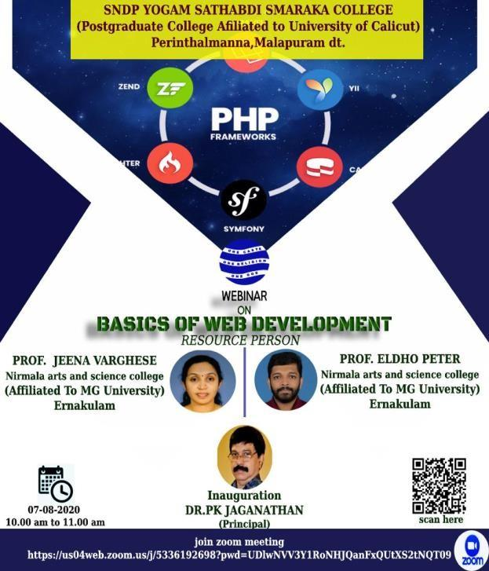
DATE: 07-08-2020 , TIME:10.00 AM PLATFORM: ZOOM
CONDUCTED BY: Mr. ELDHO PETER & Ms. JEENA VARGHESE

ORGANIZED BY : SNDPYSS COLLEGE, AFFILIATED TO CALICUT UNIVERSITY, PERINTHALMANNA

Appointed as Resource Persons for conducting the FEP for the topic “ BASICS OF WEB DEVELOPMENT” was organized by the department of computer science, Sndpyss College, affiliated to calicut university, Perinthalmanna. The programme was inaugurated by Dr. P K Jaganathan, Principal, SNDPYSS College.The event was conducted in two sessions. The first session was handled by Mr. Eldho Peter , he was presented the recent trend in web programming and next, the practical session was handled by Ms. Jeena Varghese. More than 100 participants , including various department faculties and students have participated in this FEP. After the
session , the faculties and students interacted with their question session. And, the session ended with a vote of thanks delivered by Mr. Prameesh T P , FEP Co-ordinator.
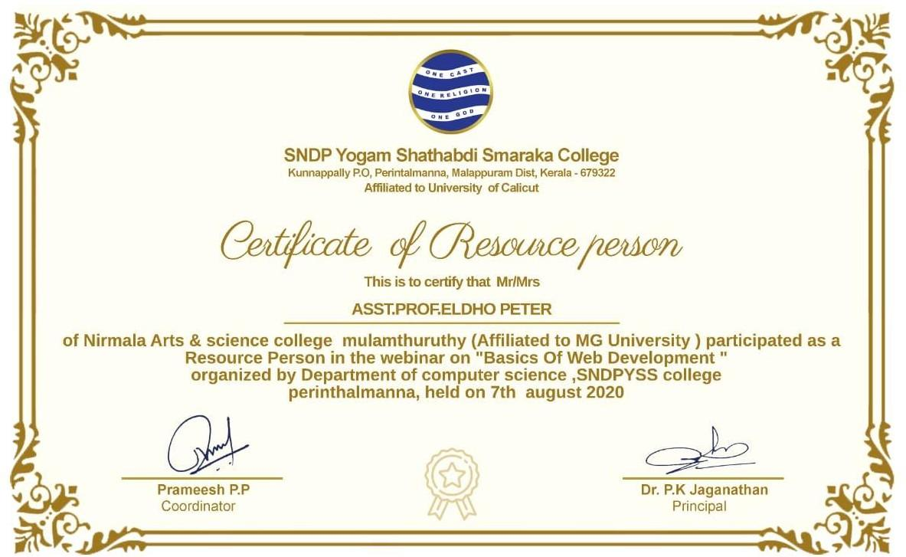
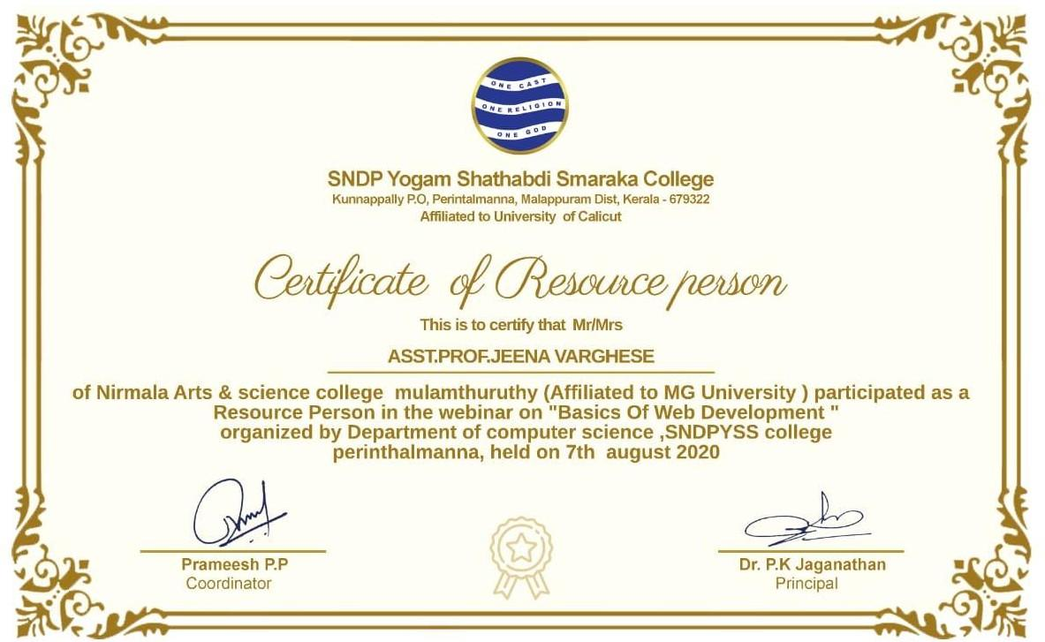

International Webinar on Python
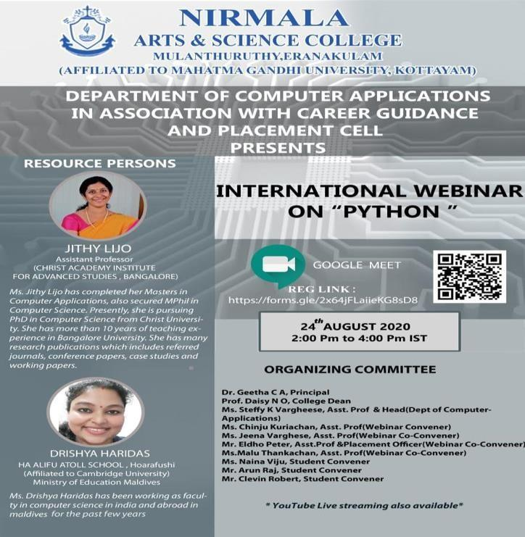

The Department of Computer Applications in association with Career Guidance and Placement Cell of Nirmala Arts and Science College, Mulanthuruthy conducted a webinar on “Python” for Students, faculties and employees of various institutions/organizations from different countries on 24th August 2020 at 2.00pm through Google Meet platform and YouTube live streaming.
The aim of the webinar was to increase knowledge on the most popular language Python and its scope in today’s IT industry. There were totally 200 registrations from various institutions in India, UK, US, Netherlands, Japan, Singapore, Kuwait & Australia. 100 participants were joined in the webinar via Google Meet platform.
Ms.Jithy Lijo , Asst Professor from Bangalore University and Ms. Drishya Haridas, Faculty of Computer Science from Cambridge University were the resource persons .
The webinar started with the introductory Speech by Ms. Chinju Kuriachan, Asst. Professor, Department of Computer Applications, the coordinator of the webinar. Followed by the welcome address by the HOD of Computer Applications Ms. Steffy K Vargheese, the Principal of Nirmala Arts and Science College Dr Geetha C A congratulated the department and the placement cell for the conduct of the webinar. The college Dean Prof. Daisy N O has delivered felicitation for all the participants and coordinators.
The webinar was conducted as two sessions. The first session was handled by Ms. Drishya Haridas from Ha Alifu Atoll School, Ministry of Education, Maldives shared her profound knowledge on the topic : Basics of python and its future scope.. The next session was carried out by Ms. Jithy Lijo, Asst. Professor of Christ Academy institute for Advanced Studies, Bangalore. She projected on comprehending the theoretical concepts and relating to practical aspects of python. This enabled the participants to have clear perception on the topic.
The informative and fruitful sessions remained interactive with vigorous and lively performance of the participants. A feedback of the session was collected from all the participants to improve the sessions that will be conducted in the mere future. The Certificate for all the participants was sent through Email.
The webinar ended at 4.30pm with the official vote of Thanks by Ms. Jeena Varghese, Asst. Professor of Department of Computer Applications.
The objective of the webinar was achieved. The overall session benefited the faculties and students. This webinar would help them to do their implementation in the area of programming.

Registration Form
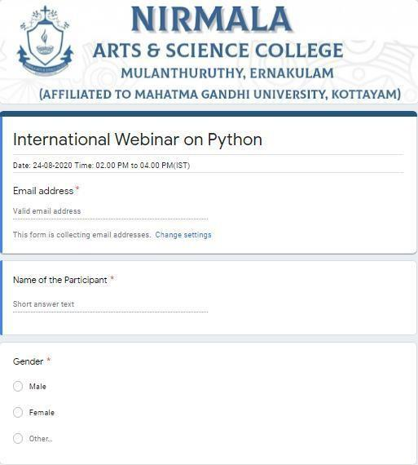
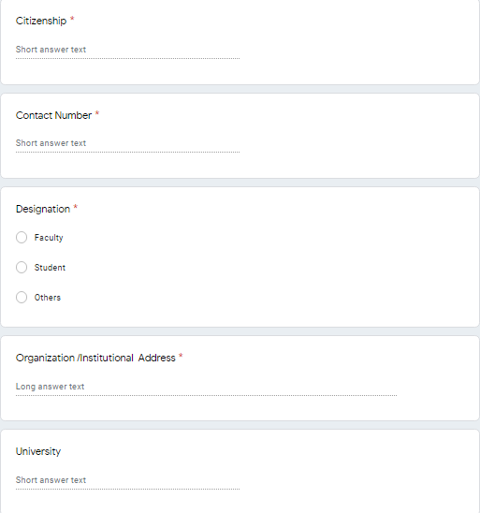
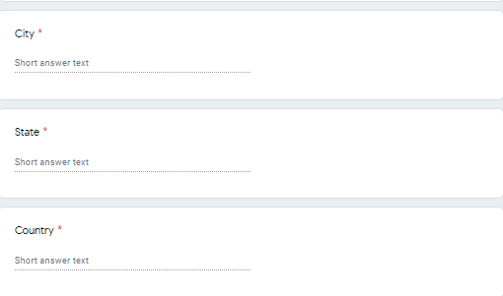
Screenshots
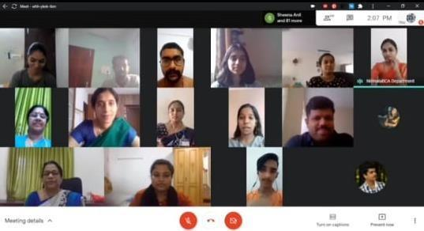

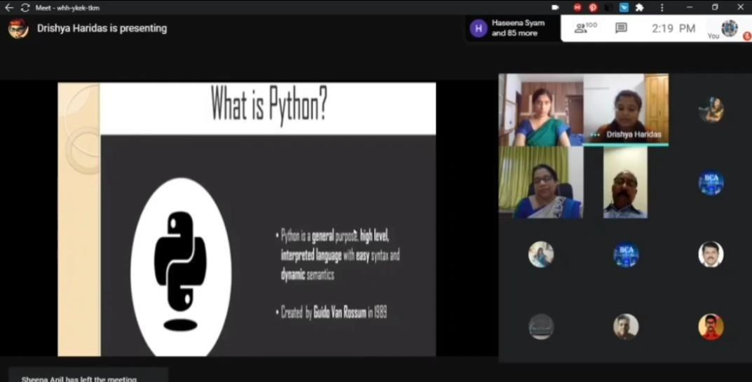

Feedback Form
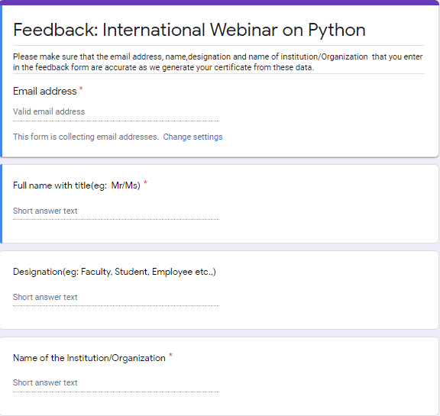
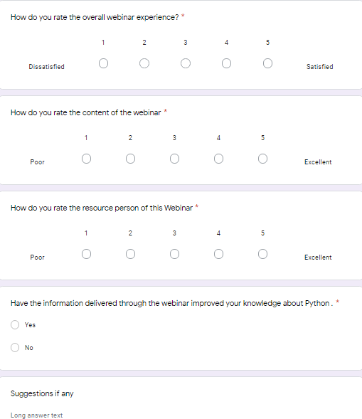
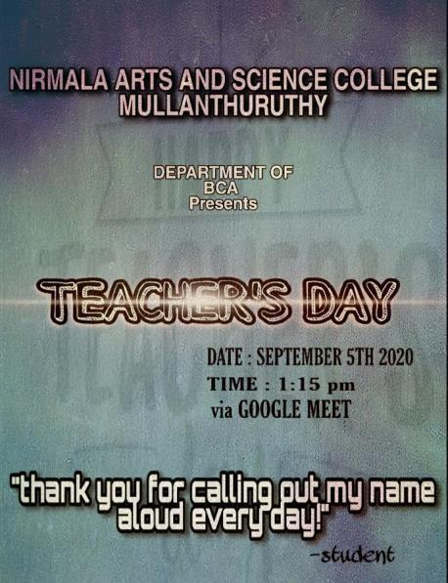
Teachers Day Celebration
The students in the department of Computer Applications decided to make their teacher’s day more happier & enjoyable. For that, Department students presented a Teacher’s Day Program, on September-5th 2020, 1:15pm via Google Meet platform. They made so much of fun games and tricky questions for their teachers. The teacher’s were surprised to see their initiative on
this program and teachers were enjoyed well.
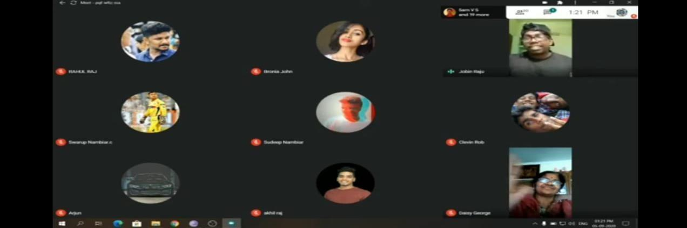

Faculty Exchange Programme
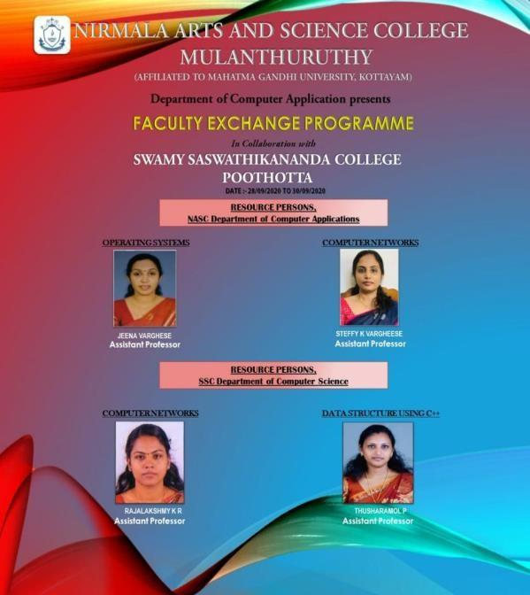

The department of Computer Applications of Nirmala Arts and Science College conducted a three day Faculty Exchange Program on 28th to 30th September 2020 in association with department of Computer Science in Swamy Saswathikananda College Poothotta.
As part of the planning phase of this program a proposal was send to Swamy Saswathikananda College and a MOU was signed. A brochure was designed and distributed to spread awareness about this program.
The aim was to enhance our skills of teaching concepts practically by conducting this type of faculty exchange programs . With this aim, two faculties from our department Ms. Jeena Varghese handled “ operating systems ” for third semester BCA students and Ms. Steffy K Vargheese handled “ Computer Networks ” for fifth semester BCA students. And two faculties from Swamy Saswathikananda College Ms. Rajalakshmy K R handled “ Computer Networks ” for fifth Semester BCA students and Ms. Thusharamol P handled “ Datastructure using CPP ” for third semester BCA students. The FDP program received an overwhelming response from all the students from both the colleges .

Date :28th September 2020(First Day)
In the first day, FEP program started with a welcome and introduction to the resource person and this followed by the session.
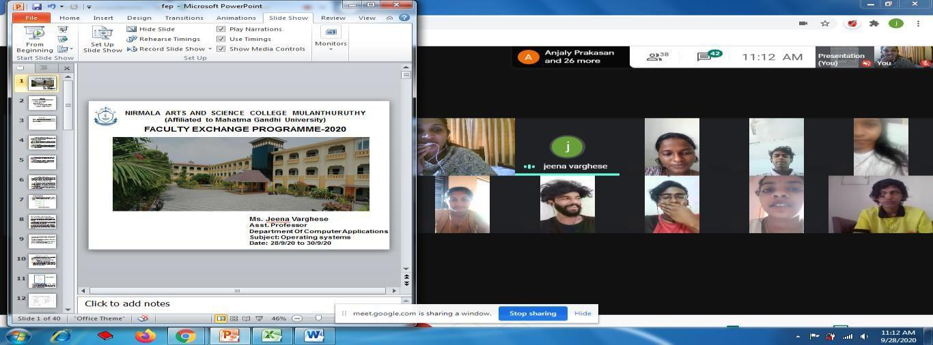

Fig: Day 1 screenshot of Operating System class
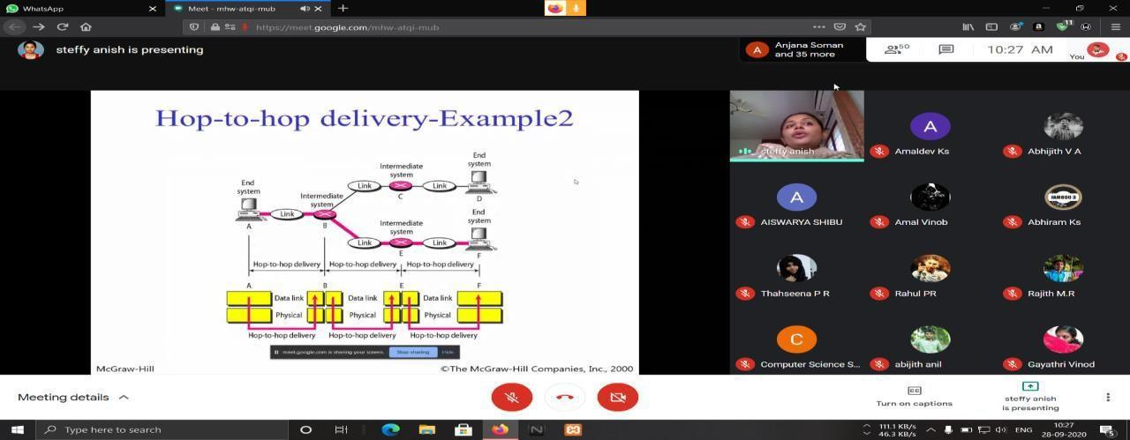

Fig: Day 1 screenshot of Computer Networks class

Date :29th September 2020(Second Day)
Second day also had very interactive sessions. There was active participation from students during the question and answer time following each session.
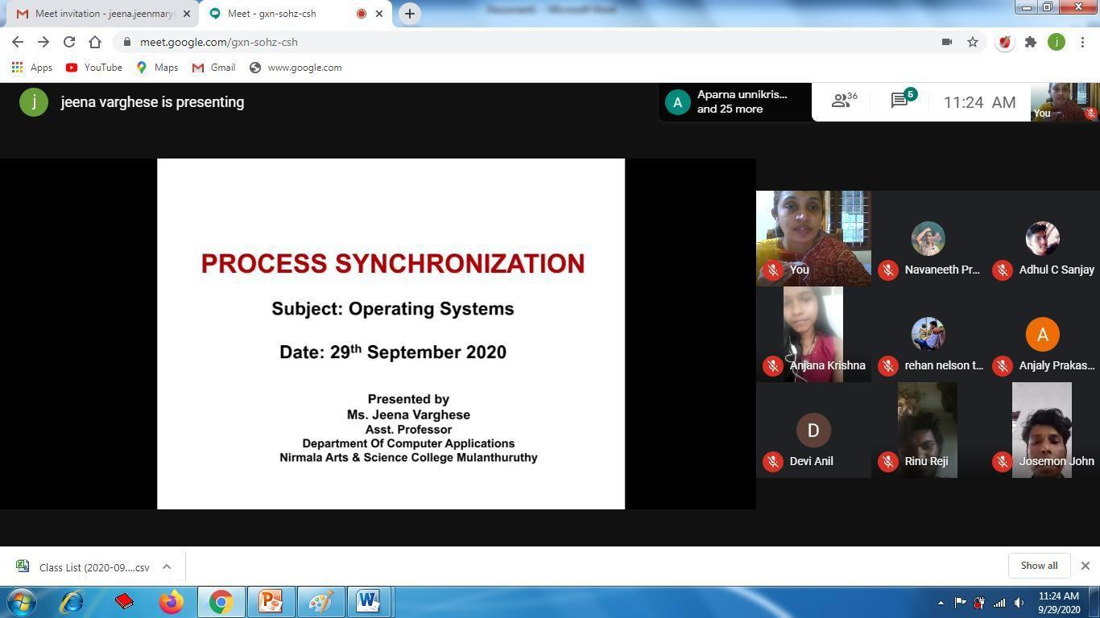

Fig: Day 2 screenshot of Operating System class
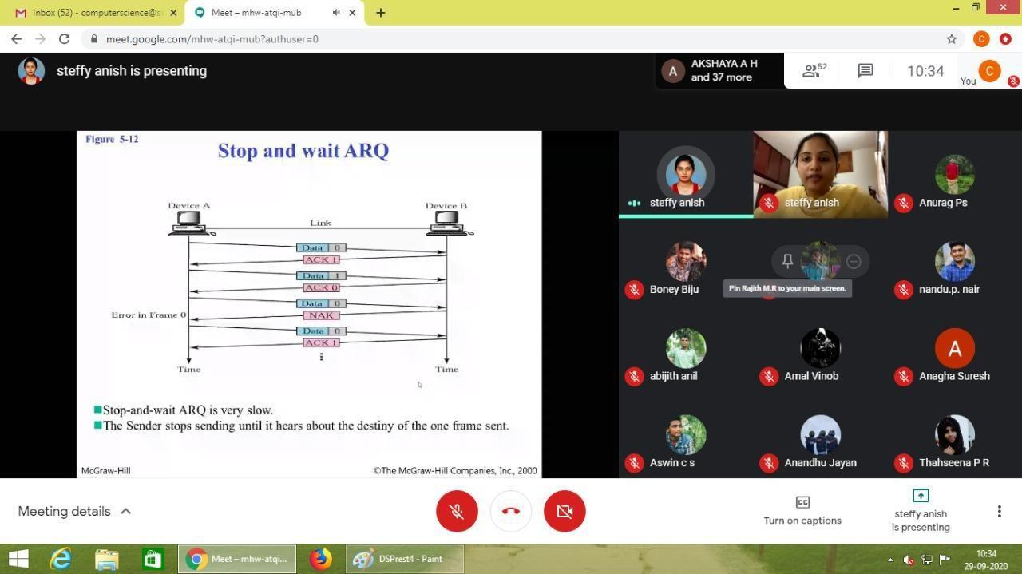
Fig: Day 2 screenshot of Computer Networks class

Date :30th September 2020(Third Day)
In the last day of FEP programme, the teaching session was followed by a felicitation ceremony to honour all the teachers who had made this programme a great success. A feedback form was given
by the resourse persons to the corresponding classes which would enable us to conduct these programmes much more efficiently in the future.
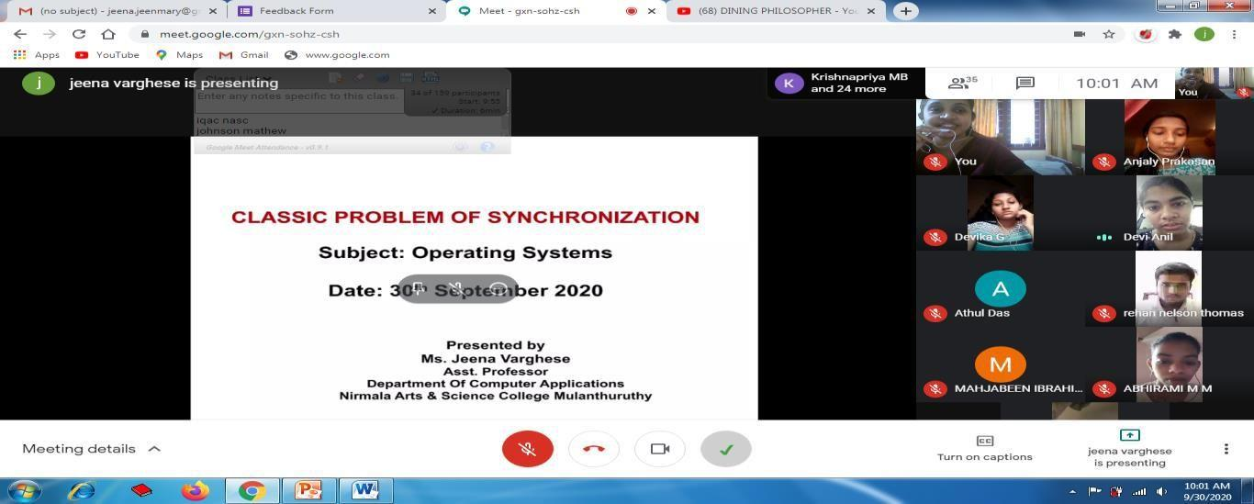
Fig: Day 3 screenshot of operating system class
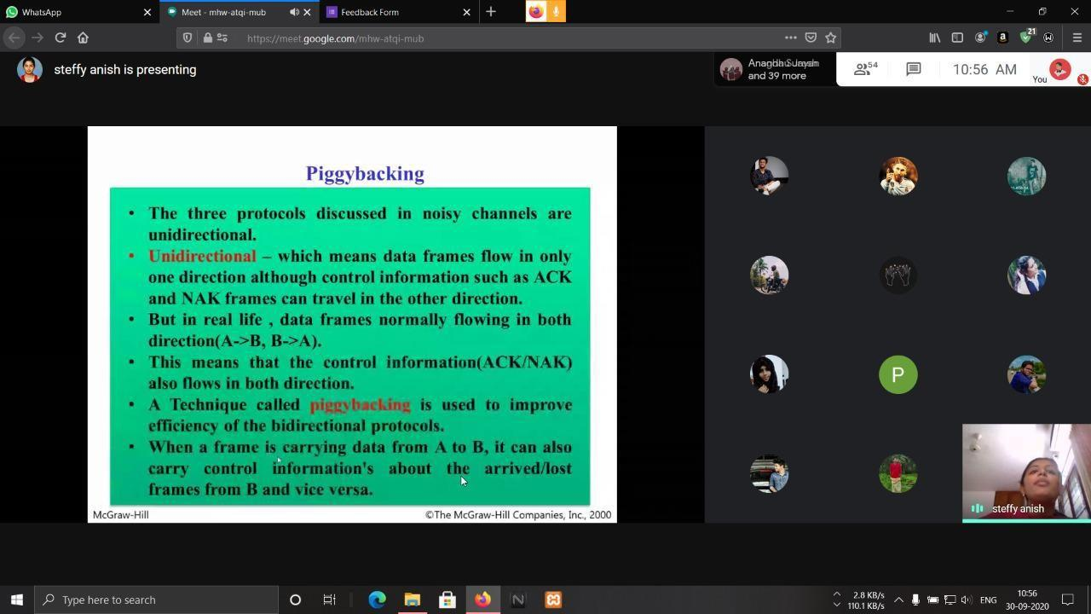
Fig: Day 3 screenshot of Computer Networks class

Resource Person: Ms. Jeena Varghese, Assistant Professor
Subject: Operating Systems
The following feedback was received from the students:
- 99% of the Students felt that the delivery and presentation of the resource person was good.
- Students felt that such FEP Program was coordinated very well.

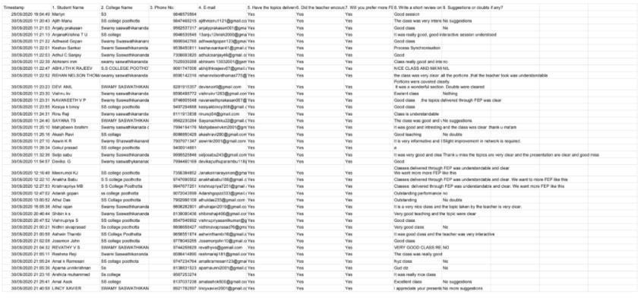

Fig: Screenshot of feedback (Operating System class)

Resource Person: Ms. Steffy K Vargheese, Assistant Professor
Subject: Computer Networks
The following feedback was received from the students:
- 99% of the Students felt that the delivery and presentation of the resource person was good.
- Students felt that such FEP should be arranged regularly.

Fig: Screenshot of feedback (Computer Networks class)

Webinar on Future with Artificial Intelligence
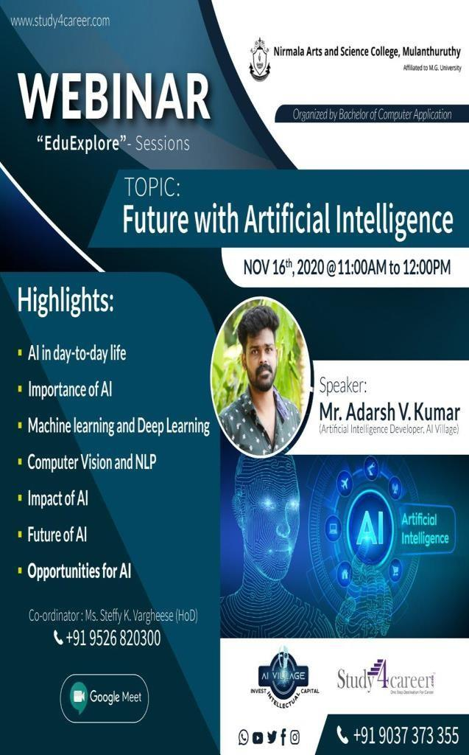
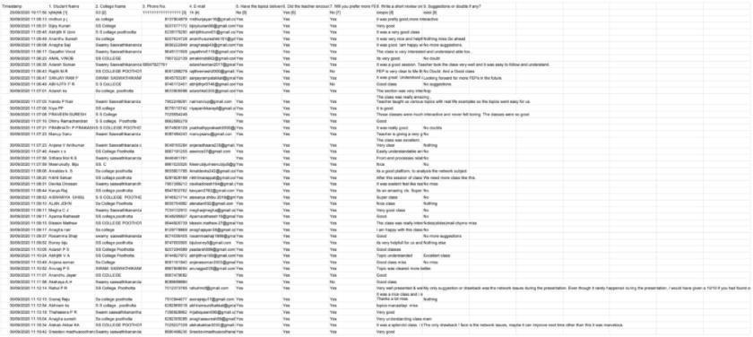
Ensuring that education is not obstructed during the lockdown, our Nirmala Arts and Science College in association with BCA department, conducted a webinar on “ Future with Artificial Intelligence “. It was held on 16th November, 2020 from 11am to 12pm. The speaker of this webinar was Mr. Adarsh V Kumar, who is an artificial Intelligence Developer in AI Village. The coordinators were BCA department HOD, Steffy K Vargheese and Assistant Professor, Eldho Peter and the student coordinator were Jenin Jaijo and Bronia John of the third year.

The webinar started with a wonderful and energetic welcome speech by Mr. Eldho Peter. Then Mr. Adarsh V Kumar spoke on the topic. He explained very well about the importance of Artificial Intelligence and its uses in our day to day life. He also described briefly the impact and future of Artificial Intelligence and job opportunities n this field. Lastly, the vote of thanks was given by Miss. Bronia John.

The overall class conducted very successfully and was very beneficial for all those who attended the event.
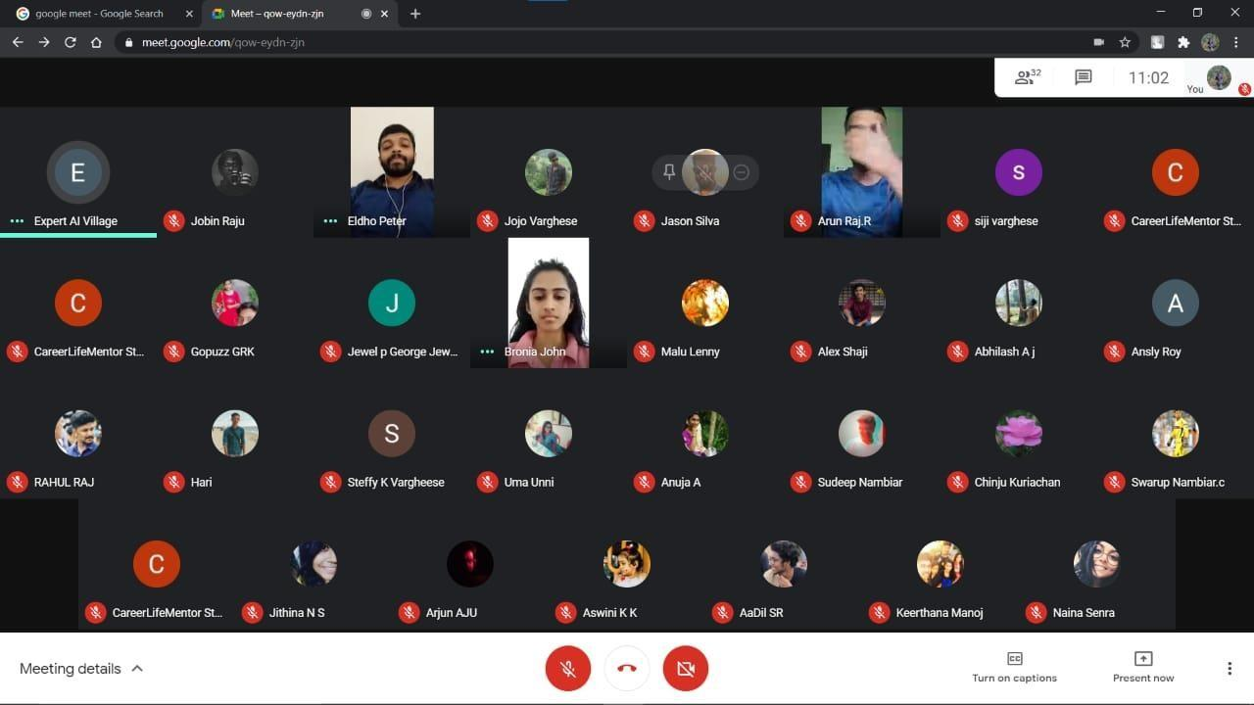

Association inauguration 2020 & World Computer Literacy Day Celebration

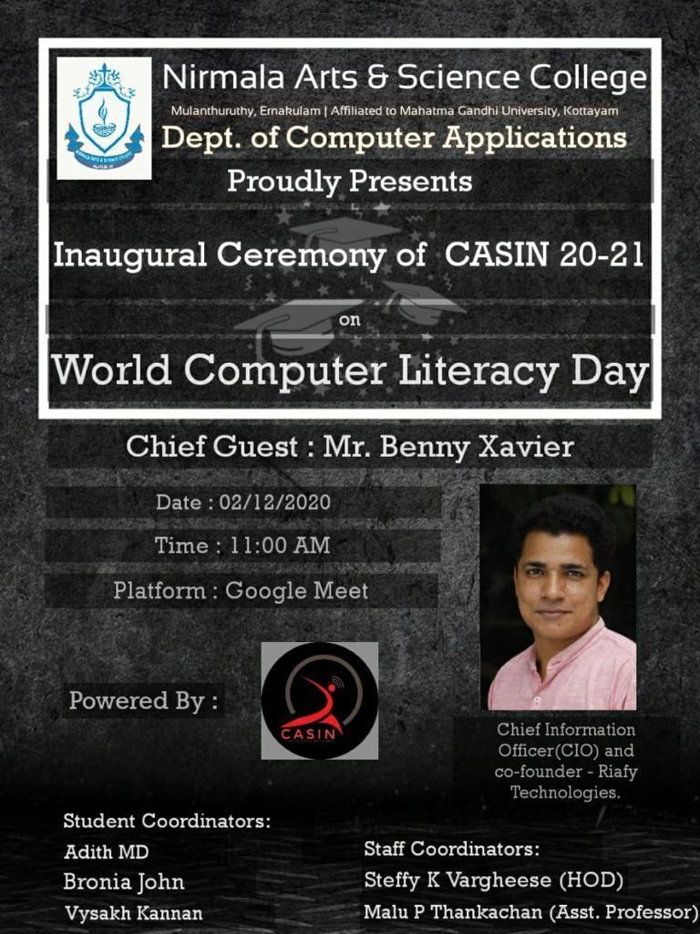

Department association day has been conducted on 2nd December by Computer Association of Students in Nirmala, at Nirmala arts and science college Mulanthuruthy. The Resource person was “Mr.Benny Xavier”, Chief Information Officer(CIO) and Co-Founder of Riafy
Technologies The planned objective was to inaugurate the association and interact with the resource person “Mr Benny Xavier”, and conducted successfully.
“Mr. Benny Xavier” Inaugurated the ceremony followed by welcome speech delivered by Department HOD “Ms. Steffy K Varghese “. Dr. Geetha mam, Principal of Nirmala Arts and Science College delivered principals’ address. Prof.Daisy N.O, Dean of the college felicitated the gathering. Short video presentation showing a look back of last year’s association inaugural function was done. There was a session handled by resource person “Mr. Benny Xavier” which helped students to know more about latest job trends and how-to start-up a company.
He shared his own experience on how to start a new company and what all failures and success he faced during his journey. He interacted with many realistic examples which helped students to get real idea on various aspects like how to start career, which all area should be improved, what are the major criteria to gain success, how to handle failures and also how you can help the society through your start-up venture. The session was wind up by Q and A New association secretary (Jenin Jaijo, Final year BCA) and treasurer (Hari, Second Year BCA) for the year 2020-2021 were announced by Ms.Jeena Varghese, Asssiatant Professor,BCA
Sudeep Nair, final year student of BCA Department delivered vote of thanks

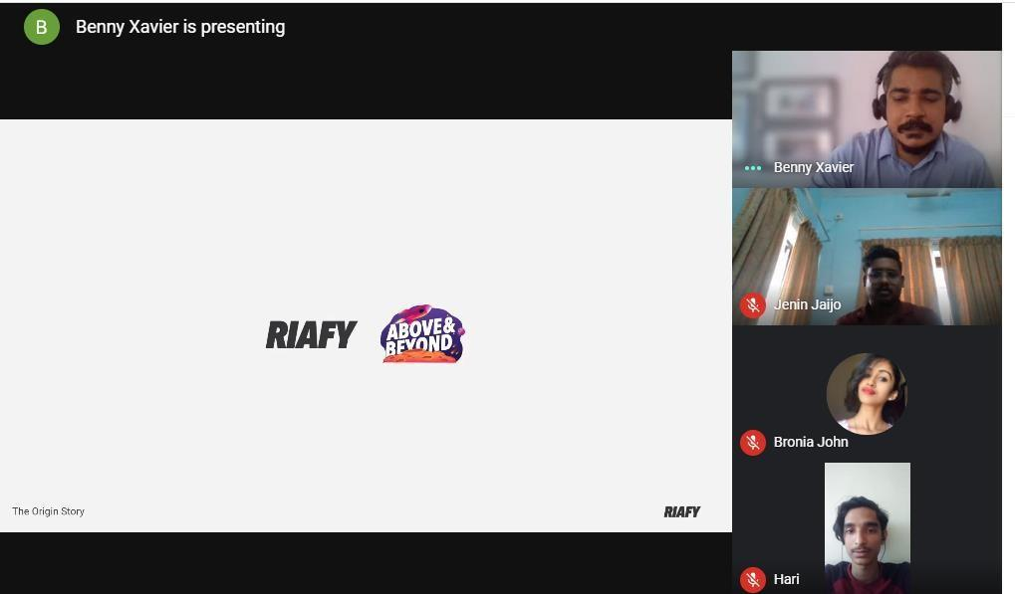
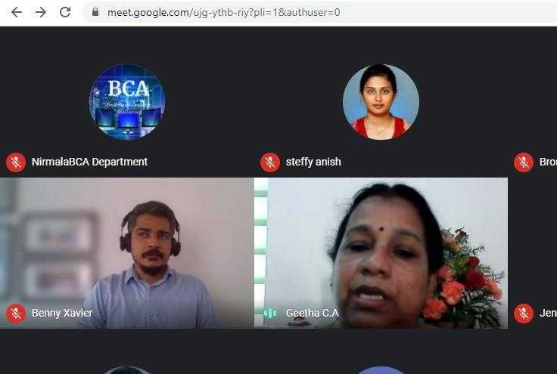
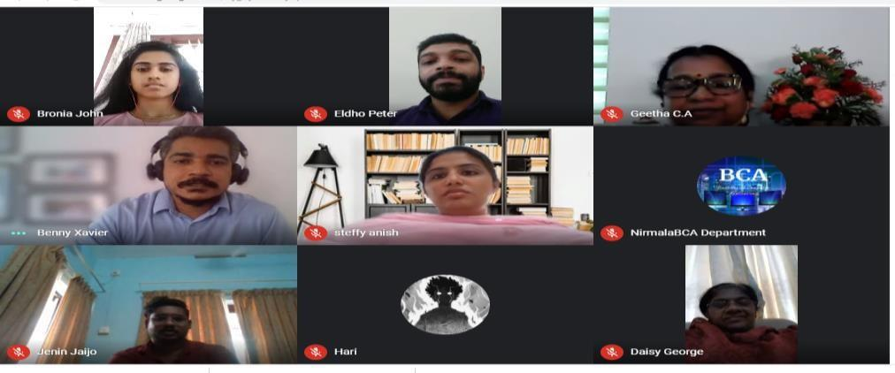

Alumni Meet
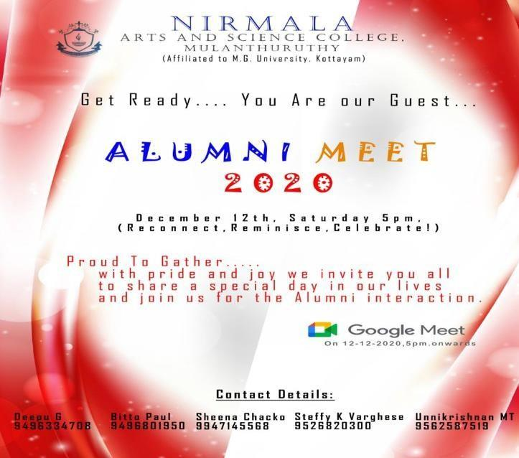

On behalf of Department of Computer Applications, Nirmala Arts and Science College, Mulanthuruthy organized Virtual Alumni Meet-2020 on 12th December 2020 through Google Meet. The progam began with college prayer. Ms.Jeena Varghese, Asst. Professor, Department of Computer Applications welcomed the virtual gathering. The event was attended by more than 50 alumni of Department of Computer Applications from different parts of the world which included UK, Canada, etc. Dr. Geetha C A, Principal of NASC ,in her presidential address, expressed happiness on overwhelming response from the alumni. She urged the alumni to contribute in enhancing Knowledge and skill domains of currents students by conducting guest lectures, webinars, seminars for providing all the necessary support and direction for the college to move forward. she also thanked the alumni for their active participation. She complimented and congratulated COVID-19 warriors for their untiring work during the prevailing pandemic.
Ms. Steffy K Vargheese, HOD, Department of Computer Applications , expressed her gratitude and experience towards alumni and congratulated the alumni for achieving the heights in their field of work. Next, ,Jobin Raju , 3rd year BCA student dedicated a song for our Alumni. Then Ms. Chinju Kuriachan, Asst. Professor, facilitated the gathering by sharing her memories regarding the alumni. Alumni team of the college had prepared video showcasing cherishable memories during their college time. Some of alumni expressed their views about the college and alumni meet. Cultural program includes, recorded dance and games was conducted by the 3rd year BCA student representatives. Swarup Nambiar, 3rd year BCA student, proposed vote of thanks to all people involved in the successful conduct of the event.
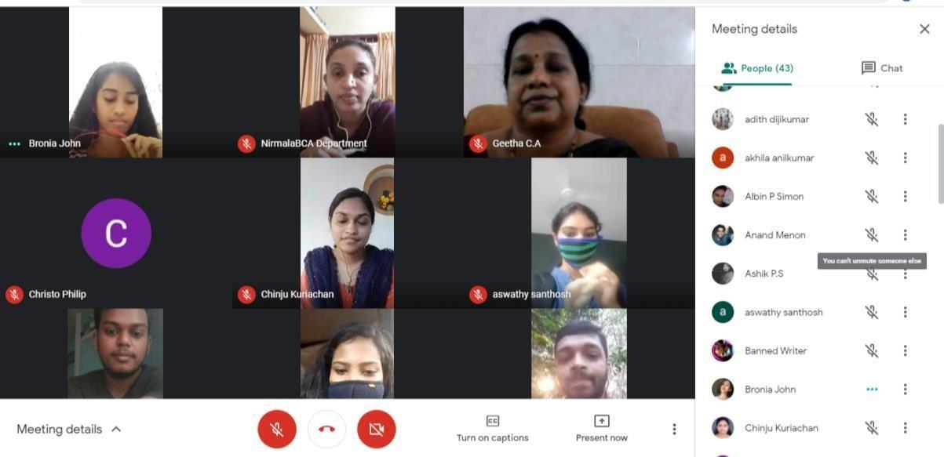
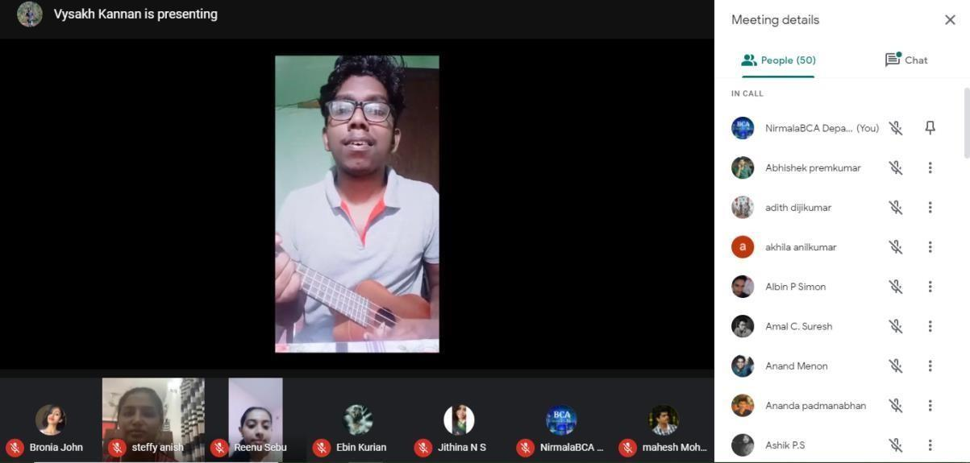

Extention Programme

DIGITAL AWARENESS CLASS FOR PARENTS-2020
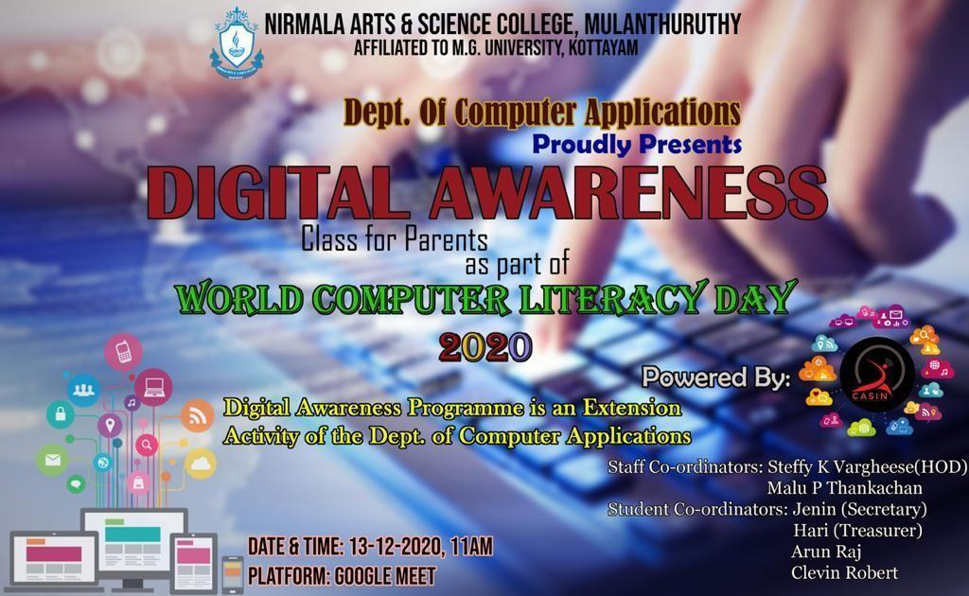

The department of Computer Applications of Nirmala Arts and Science College conducted a one day digital awareness class for parents as a part of World Computer Literacy Day on 13th December 2020 at 11am.
As part of the planning phase of this program a registration form was send to parents and interested parents were registered.
Registred parents list
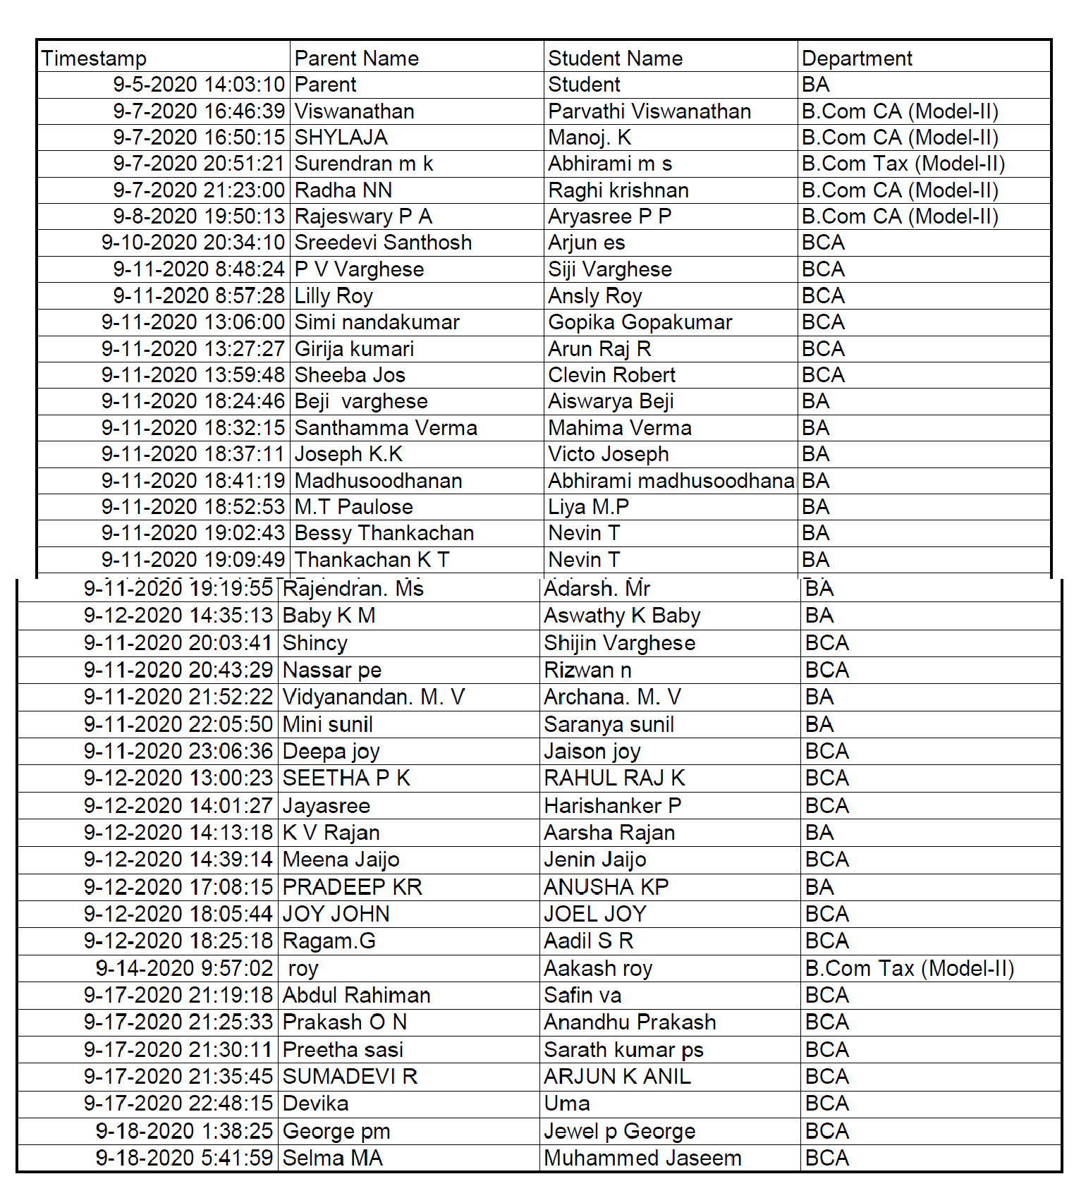

The aim of this program was to provide digital awareness skills like how to use google pay for online transactions, how to create email id and how to use it, how to use play store whatsup and also regarding google meet and you tube channel creation. With this aim, 6 students from our department participated and they handled different topics. This program received an overwhelming response from all the parents and also from the colleges. All the sessions where taken using live examples so that all parents got clear idea on each topics. Digital Awareness program started with a silent prayer
followed by welcome speech by Ansly of second year BCA. Then Department HOD Ms.Steffy K Vargheese gave a small description about the program to the parents .
The entire program was taken by BCA students and that was the highlight of program.
- By 11.15am the first session started and the topic was Gmail , play store and was handled by Hari of second year BCA. He gave detailed explanation on how to create an email account, how to send a mail, how to use play store. He explained how you can download different applications from play store and how to use it.
- Second session was G-meet- which was taken by Arun of second year BCA
- Third session was handled by Gopika of second year BCA and the topic was Whatsapp
- Fourth session topic was Youtube(Basics) and was taken by Jithina of third year BCA
- Next session was Youtube Channel creation and was handled by Sam of third year BCA Google Pay basics session was handled by Sudeep of final year BCA while the google pay
payments details including how to pay electricity bill was taken by Swaroop of final year BCA
- Siji of second year BCA delivered vote of thanks
- By the end of the session feedback form was provided to parents

Feedback Form
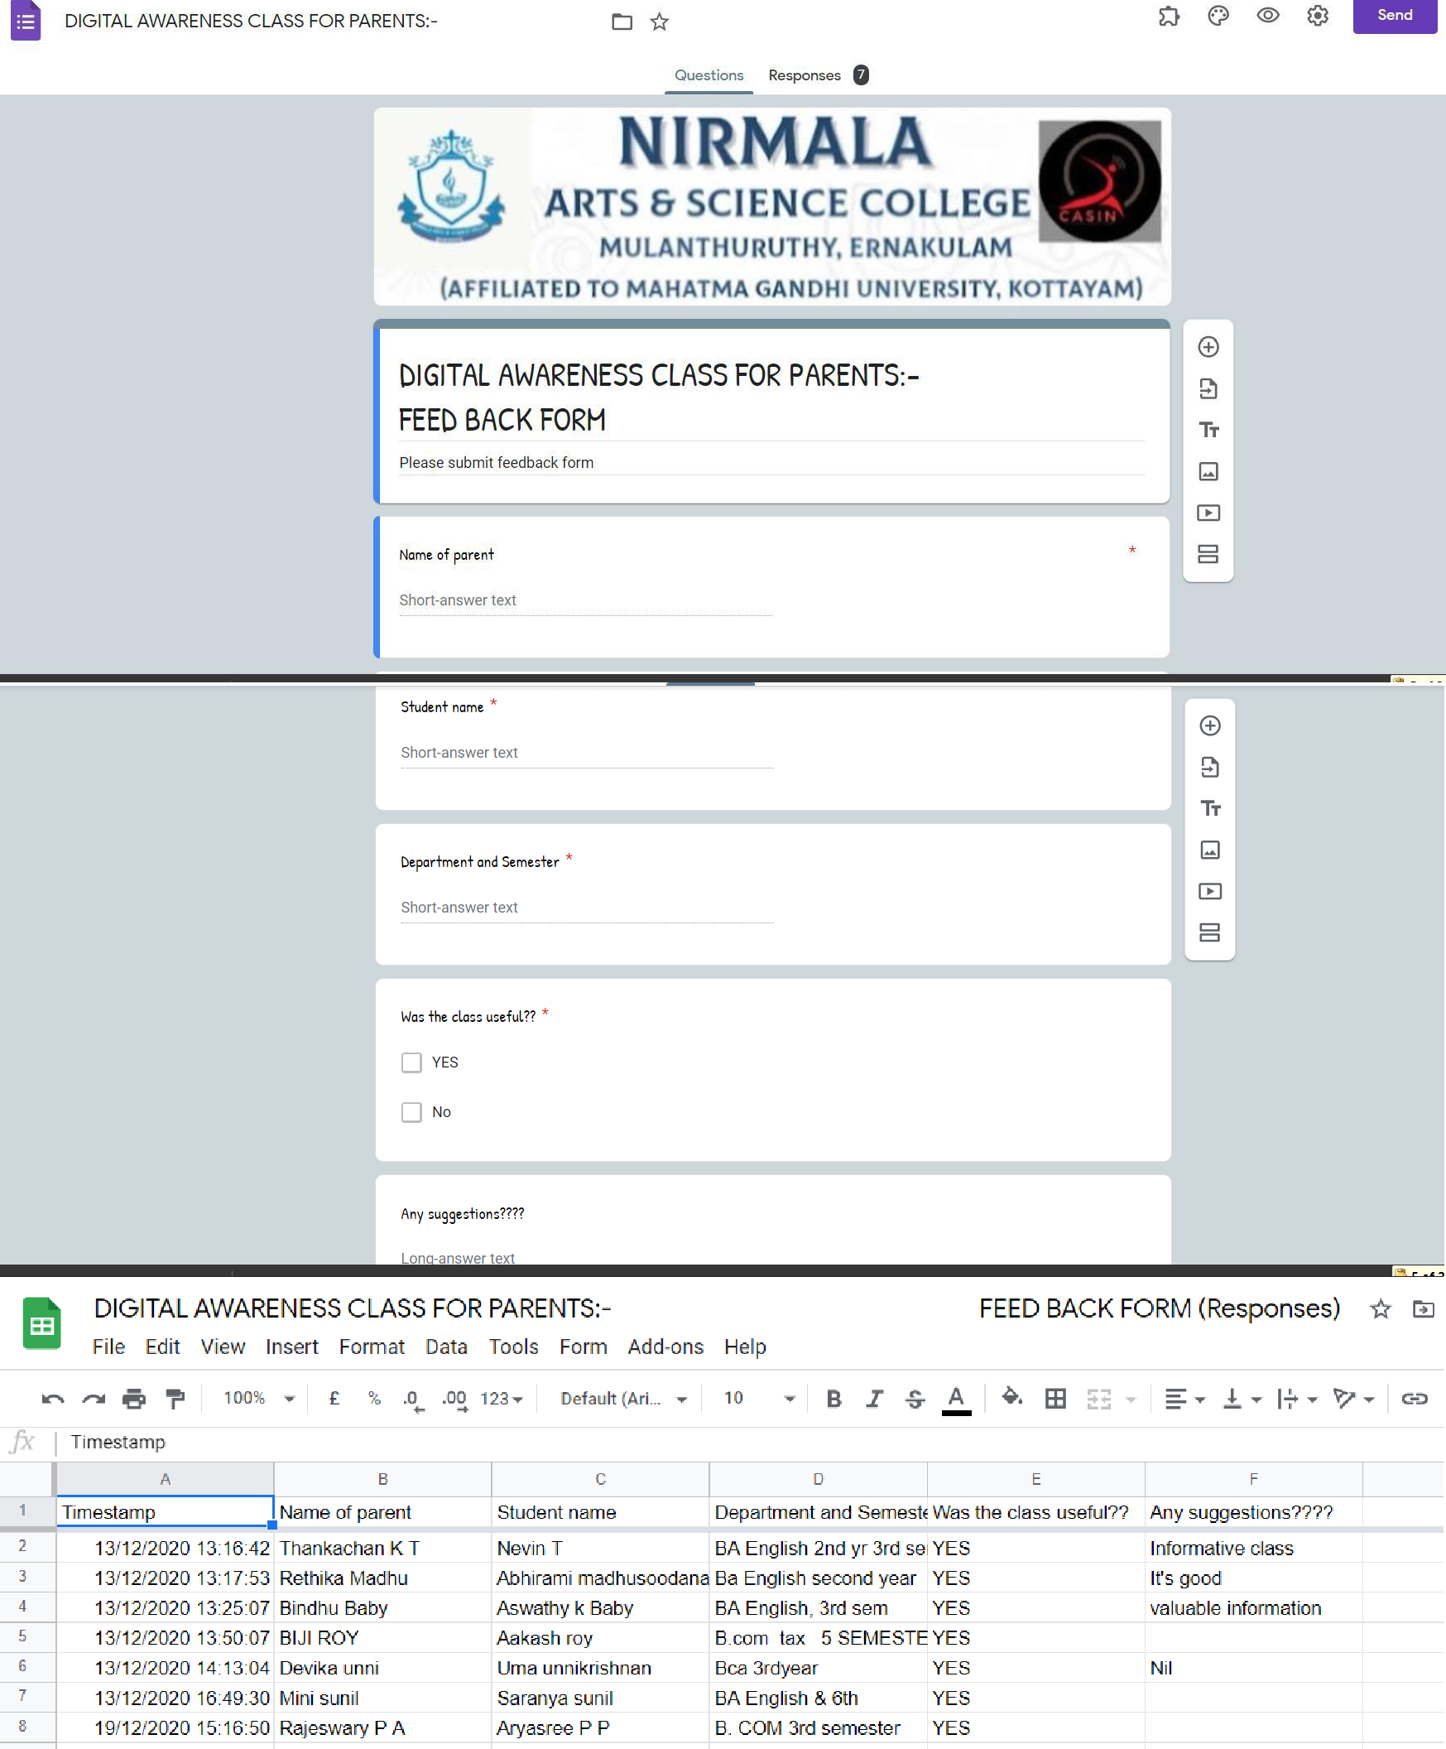
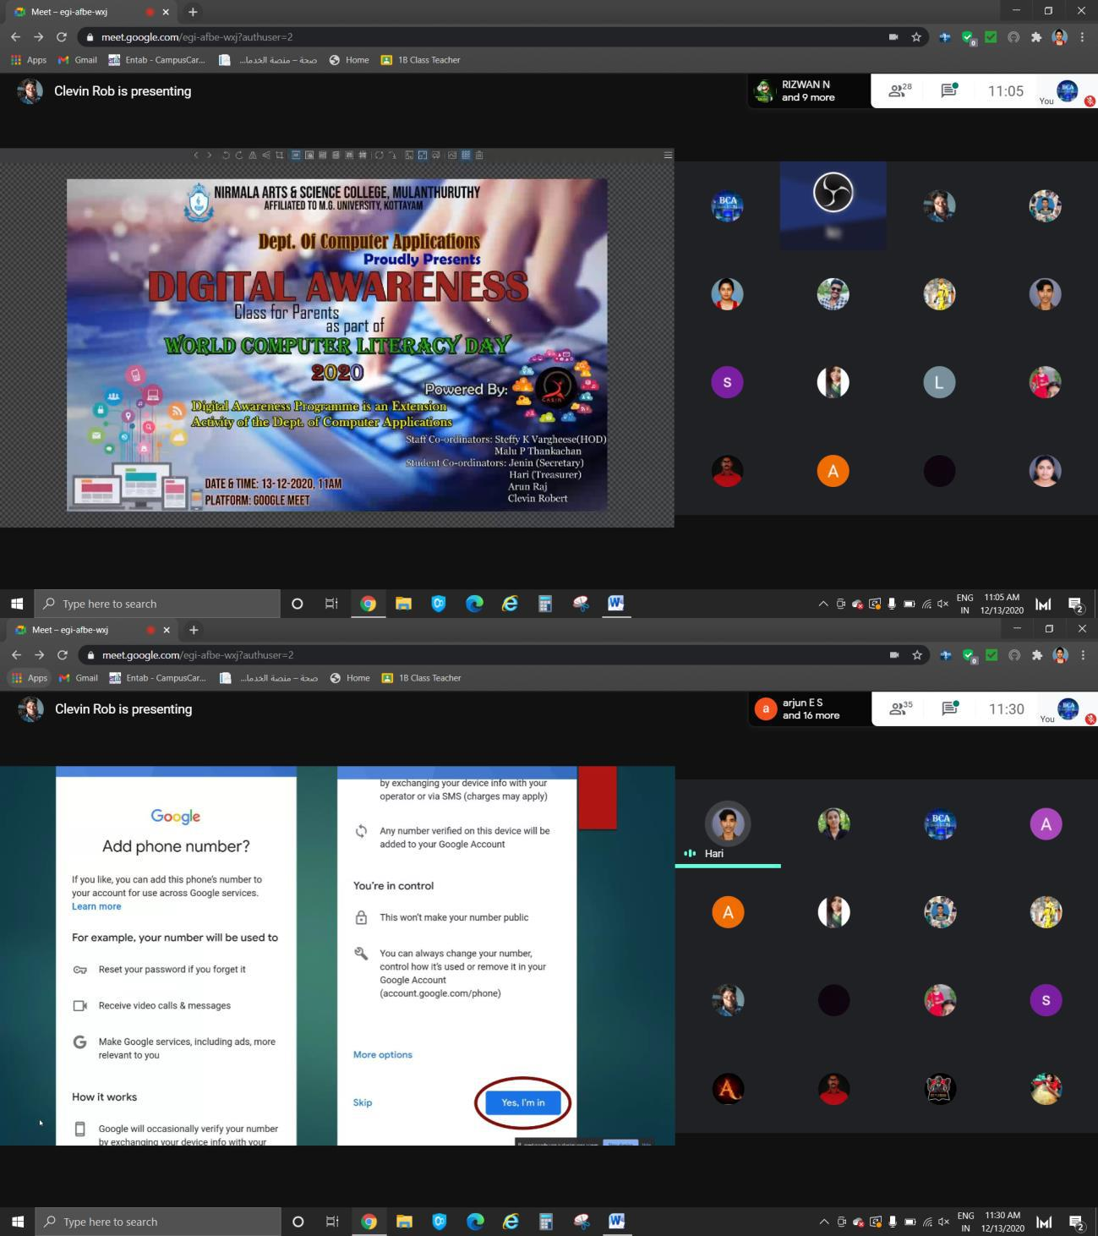
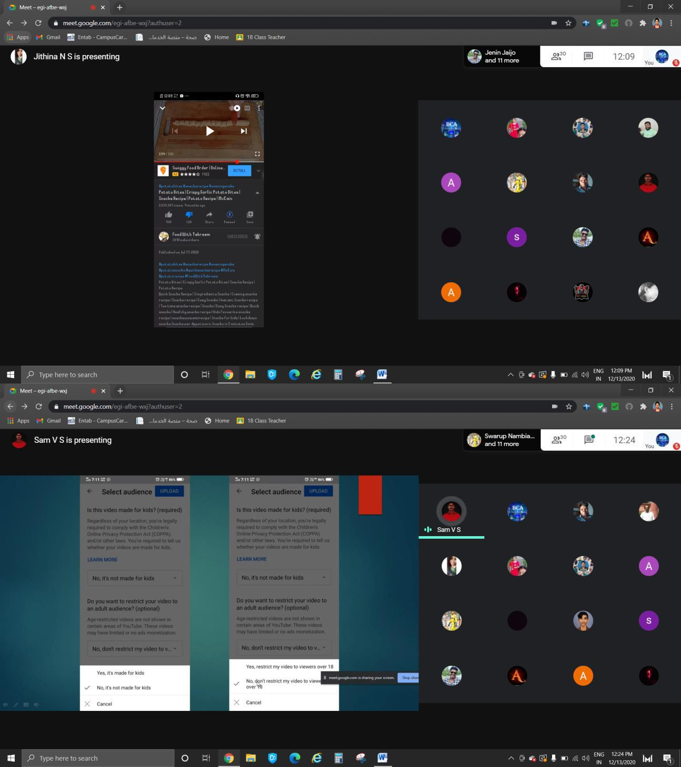
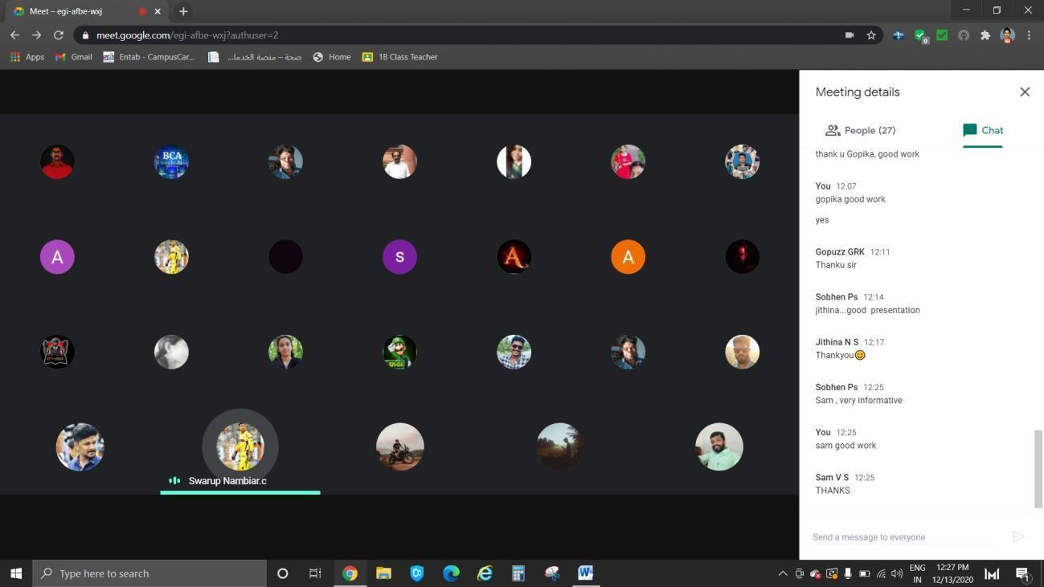

Bridge Course

OBJECTIVE OF BRIDGE COURSE:
Department of Computer Applications conducted a Bridge Course, aimed to act as a buffer for the new entrants, with an objective to provide adequate time for the transition to hard-core subjects. The students were selected by conducting an exam. Those students who secured 50% or below score, were selected for this course. During this interaction of 2 weeks (2/1/2021 to 22/1/2021) with the faculty, the students will be equipped with the knowledge and the confidence to study the course. A class of 18 students may be accompanied with 6 faculty members. It may not be on continuous days.

BCA BRIDGE COURSE SYLLABUS

Computer Architecture: Introduction, Input Devices , Output Devices, Central Processing Unit (CPU) Memory :Primary Memory, Random Access memory, Types of RAM, Read Only Memory, Types of ROM, Secondary Memory: Classification of Secondary Storage Devices, Magnetic Tape, Magnetic Disk, Optical Disk.
Data Representation in Computers: Number Systems and Logic Gates Introduction, Number Systems, Conversion between Number Bases

Computer Software: Introduction to Software, Definition, Software Categories: System Software, Application Software
Programming Language: Introduction, Classification of Programming Languages, Computer Programs: Introduction, Developing a Program, Algorithm, Flowchart

Operating System: Introduction, Functions of an Operating System, Modern Operating Systems, Data Communication and Computer Network: Introduction, Transmission Media, Network Topologies,
Internet: Basis Introduction, Basic Internet Terms, Getting Connected to Internet, Internet Applications: Electronic Mail, Searching the Web (Search Engines), Computer Viruses and Anti viruses

Basic statistics and Introductory Probability Theory: Introduction to statistics, Population and Sample, Collection of Data, Census and Sampling, Methods of Sampling Simple Random Sampling(with and without replacement) stratified sampling systematic sampling (method only), Types of data quantitative,
qualitative, Classification and Tabulation, diagrammatic representation-Bar diagram, Pie diagram

QUESTIONS FOR BRIDGE COURSE (BCA)

Total marks-10

The symbols used in an assembly language are

Code
    - Mnemonics

Assembler
    - All of the above
    - None of the above

ASCII stands for

American standard code for information interchange
    - All purpose scientific code for information interchange

American security code for information interchange
    - None of the above

The list of coded instructions is called

Computer program
    - Algorithm

Flowchart
    - Utility programs

Which of the following retains the information it’s storing when the power to the system is turned off?

CPU
- ROM

RAM
- DIMM

A network of computers and other devices that is confined to a relatively small space is called?

Wide Area Network
- Local Area Network

Global Network
- Peer-to-Peer Network

Which of the following statement is correct?

1 KB = 1024 bytes
- 1 MB=2048 bytes

1 MB = 1000 kilobytes
- 1 KB = 1000 bytes

The output shown on the computer monitor is called

VDU
    - Hard copy

Soft copy
    - screen copy

The computer you are controlling or working via a network is called?

Remote computer
- Local computer

Host computer
- Personal Computer

The Operating System is a:
    - System Software

Application Software

Utility Software

Malware

CPU can access memory directly.

Main memory

External memory

Secondary memory

All of the above

Answer key
B
A
A
B
B
A
C
A
A 10.A

STUDENT LIST FOR BRIDGE COURSE

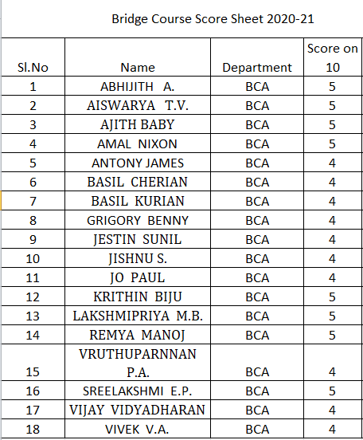

SCREENSHOTS
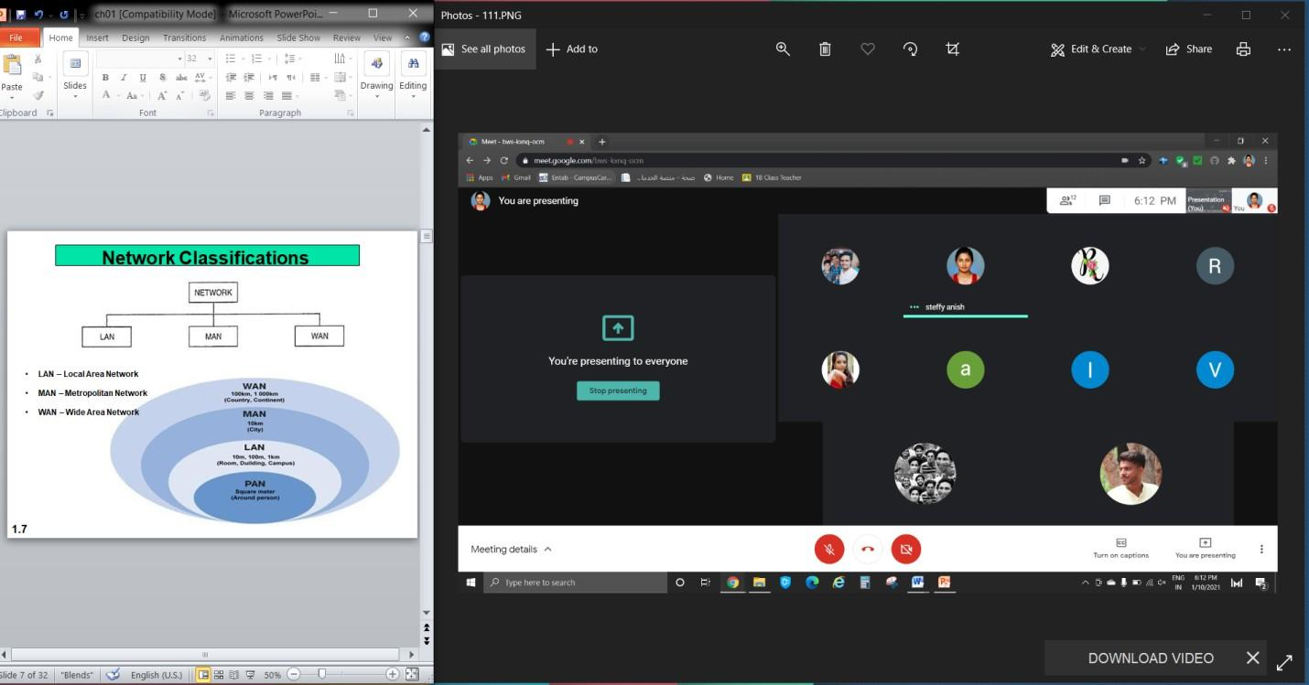

Bridge Course Evaluation Test

- Expand EPROM.
- Convert (25)₁₀ to binary.
- What are the different universal gates
- Write an example of Application software.
- Differentiate Algorithm and Flowchart
- Write 3 types of guided media
- Define Operating Systems.
- What are the components of Email.
- What are Trojan Horses?
- What do you mean by random sampling?

ABHIJITH A.
AISWARYA T.V.
AJITH BABY
AMAL NIXON
ANTONY JAMES
BASIL CHERIAN
BASIL KURIAN
GRIGORY BENNY
JESTIN SUNIL
JISHNU S.
KRITHIN BIJU
LAKSHMIPRIYA M.B.
REMYA MANOJ
RUTHUPARNNAN
SREELAKSHMI E.P.
VIJAY VIDYADHARAN
VIVEK V.A.
JO PAUL

PTA Meeting Report.
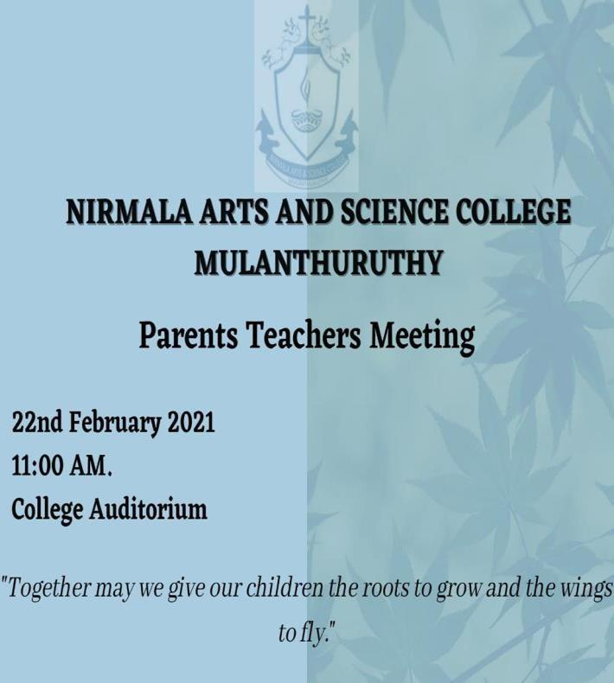

The first PTA meeting of the academic year 2020-23 was held on 22nd February at 11 am. Around 90 percent of parents and students attended the function The programme began with college prayer. Mrs. Steffy K Vargheese Head of the department welcomed the gathering. Manager Mr.George Kuriakose,Principal Dr. Geetha CA, Dean Prof.Daisy N.O and Vice Principal Dr.Murali offered felicitation. The Principal welcomed all the parents and introduced the new changes in the administration to the parents Mrs Steffy K Vargheese Head of the Department invited all the First year teaching staffs to Stage and introduced them to parents. Discussions regarding the classes, time hours were made. Help desk were provided for parents for discussing about the add on course for Department of computer Applications -“Search engine optimization” and digital marketing. The time period for the course and its job opportunities , fees and its installments were shared with parents. Stop admission was done for the same. The PTA came to an end with the conclusion that joint effort, mutual understanding and co-operation of parents and teachers is very important for the proper nourishment and progress of students

Farewell Report(Students)
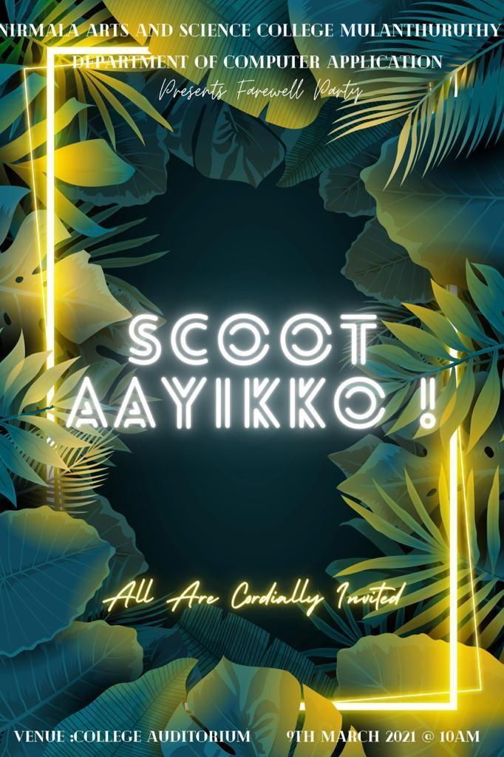
Department of Computer Applications organized farewell party “SCOOTAYIKKO” on March 9th at 10 am in the college auditorium where students of first and second years bid farewell to the outgoing students with great enthusiasm and off course nostalgia. The programme began with college prayer. The programme commenced with the address by the Principal, Dr. Geetha CA where she spoke encouraging words of wisdom for the outgoing students which was followed by a special felicitation by Manger Sri.George Kuriakose, Dean Prof. Daisy N O and vice principal Dr. Murali Proficiency prize was given to Aswini of 3rd year BCA and Sudeep of 3rd year BCA has awarded as best outgoing student A video presentation by the second years made everyone mushy. It reminded them of their yesteryears and home away from home. First year students mesmerized all by a lovely dance performance on a fusion track.The cultural events progressed with a song by Arjun anil of second year Another song was performed by Jobin Raju of final year which entertained entire gathering. Different tags were awarded to the students, tag of Miss Perfect, Miss Charming Best listener etc Teachers also shared their experience Some exciting games were also arranged for the students. Token of love and appreciation was given to the final
year students. Also Token of love was presented by students of final years to the faculty’s of department of computer applications. The programme concluded with a lunch and DJ.

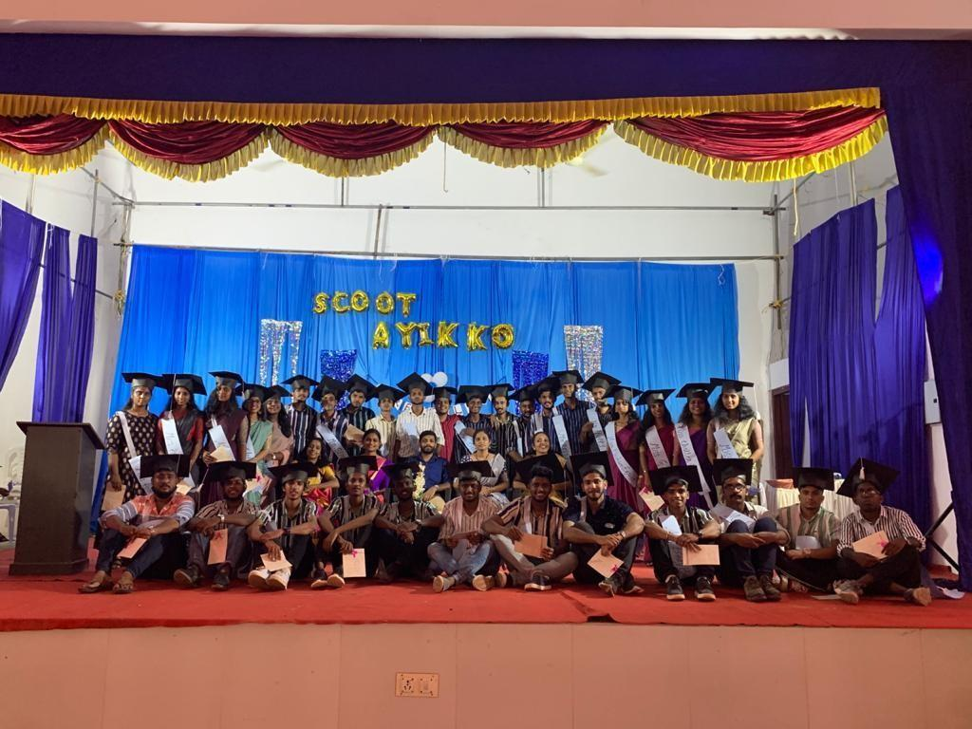

FAREWELL REPORT(Staff)
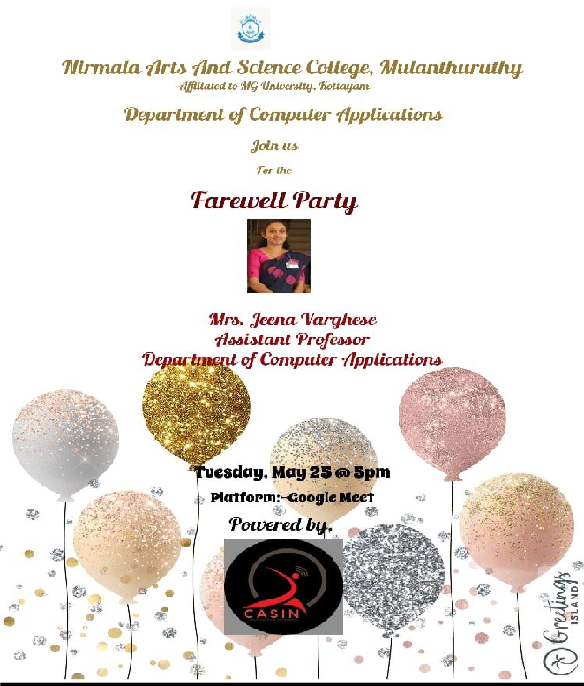

Department of Computer Applications organized farewell party of Mrs.Jeena Varghese, Assistant Professor on May 25th at 5 pm through Google Meet.
All the staff, students of department of computer applications and some guardians were present in the ceremony

Mrs.Steffy K Vargheese , Head of the Department delivered a speech about Asst.Prof Jeena Varghese and her contributions to the all-round development of the department and college
Mrs.Chinju Kuriachan , Mr, Eldho Peter and Mrs.Malu P Thankachan felicitated the gathering

They also shared their fond memories they had with Ms. Jeena Varghese and they were so touching and heartwarming.
Arjun Anil of second year and Jobin Raju of third year performed a song which stealed the show.

The highlight was a video presentation made by teachers and final year students of department of computer applications which threw fun and added life to the party.
Ron winny of first year, Harishankar of second year and Arya Regi of third year shared their experience with their beloved teacher.

They expressed their deep love and gratitude to the teacher for their teaching and motivations.
The function ended with the talk of Mrs.Jeena Varghese (after her 9 year of service in Nirmala arts and science college)

She wished the students welfare and advised them to prepare themselves to serve for better future and said how much she is going to miss the college and students
The program came to an end at about 6 p.m.
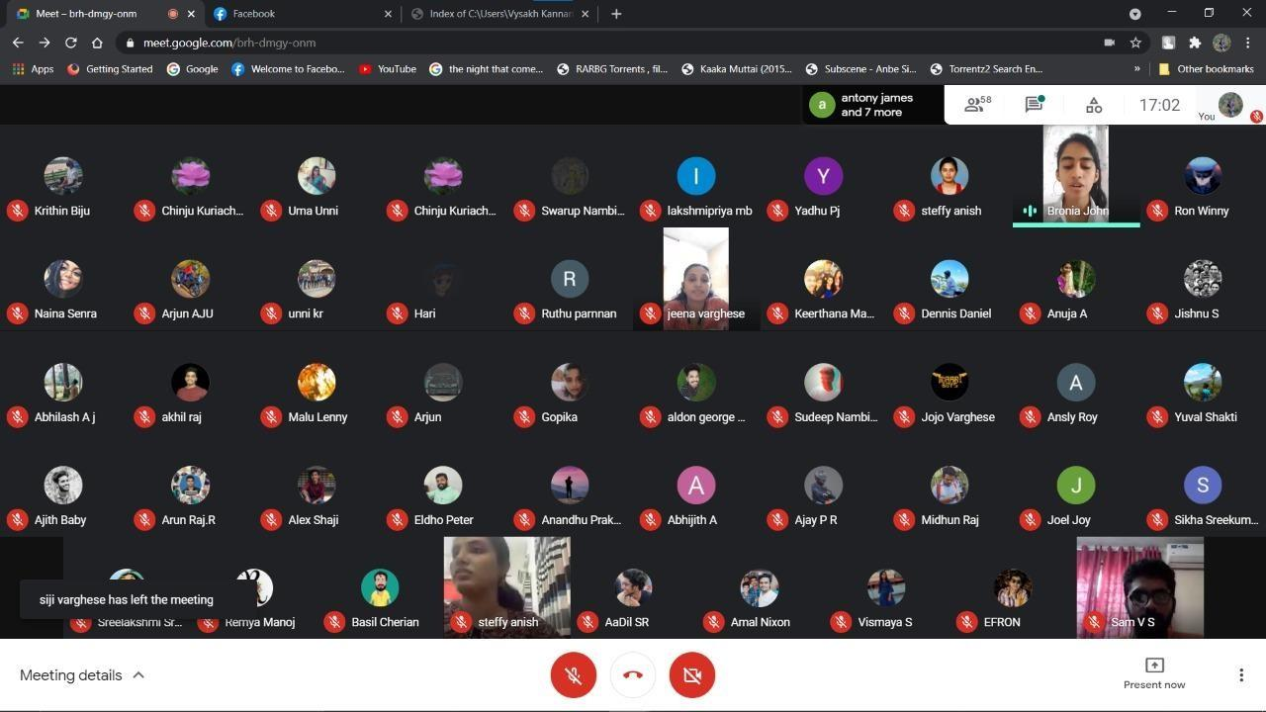

Orientation Programmes
Nirmala Arts and Science College Mulanthuruthy organized an orientation programme for the newly joined graduation students through Google meet on 30/Oct/2020.The programme had two sessions. The first session handled by Prof.Dr.Dileep Kumar - Former vice chancellor of Sree Sankara University Kalady inaugrated the event. He took his session on how the students need to be responsible citizen in the society by quoting varied examples from different facets of life. The second session handled by Shri Thankkachan,(Director of Rural Science and Technology Thuruthikkara) inaugurated the second session. In his speech he shared how the science and technology will help the students to earn a livelihood. He highlighted the good work of our college E D club. He stressed the need for cooperation by our ED club with Rural Science and technology, Thuruthikkara which will be beneficial to the ED Club.

Placement
Department of Computer Applications conducted a one day softskill training programme for BCA final year students(2020-21). This programme was conducted by faculties from department of English. The following Students from our department cleared Non voice rounds of Interview and have been shortlisted as an “Associate” in Sutherland Company during the year 2020-21.

Emmanuel Jose | Sutherland | 2020-21
Sudeep Nambair C. | Sutherland | 2020-21
Jobin Raju | Sutherland | 2020-21
Bronia John | Sutherland | 2020-21
Jenin Jaijo | Sutherland | 2020-21
Rahul k Raj | Sutherland | 2020-21
Vysakh Kannan | Sutherland | 2020-21
Naina Viju | Sutherland | 2020-21
Sam V S | Sutherland | 2020-21

Swarup Nambiar | Sutherland | 2020-21
Jithina N S | Sutherland | 2020-21
Adith M D | Sutherland | 2020-21
Arjun Vijay | Sutherland | 2020-21

